**Site name:** Bountiful Foods

**Logo:**



**Site Purpose:** This website is intended to provide all the relevant information about “Bountiful Foods” and how our customer can access to our products and services. This website will also provide information about the most popular coastal areas of California and the current weather conditions. This website will also provide the opportunity to the potential customers to explore our variety of organic foods, that has been grown locally or the ones that have been imported from several countries around the world. This website will be the place where local population and to tourists visiting the coastal areas will have the opportunity to acquire healthy, organic food and drinks in an environment that encourages healthy eating habits.

**Target audience:** First of all, the target audience of Bountiful Foods will be people who are conscious about their health and wellbeing and prefer to eat fresh and organic food. They may be looking for a healthier alternative to traditional fast-food options and are willing to pay a little bit more for it. On the other hand, we have the local population living in the coastal areas. This can include locals who prefer to buy locally sourced, fresh, and organic food products. We must take in consideration the tourists visiting the coastal areas who are looking for healthy food options while on vacation and want to try local, organic produce.

|  |  |
| --- | --- |
| **Persona 1** | **Local Yoga instructor** |
| **Photo** |  |
| **Fictional Name** | **Rachel** |
| **Demographics** | * 30 – 40 years old * Married * Mother of 1 child * Has a bachelor’s degree in nutrition |
| **Goals and tasks** | She is focused on her goals; she wants to feel good with her and her body and thinks that eating healthy food is the best option to achieve this.   * Practices yoga each morning * Wants to eat healthy food * Follow a strict organic food diet |
| **Job Title / Major responsibilities** | Yoga Instructor / Has her own yoga gym |
| **Environment** | She is surrounded by people with her own lifestyle, she likes to share healthy food recipes and encourages people to live a healthy life. |
| **Quote** | “Never underestimate the power of good food and regular exercise” |

|  |  |
| --- | --- |
| **Persona 2** | **Tourist** |
| **Photo** |  |
| **Fictional Name** | **Josh** |
| **Demographics** | * 30 – 50 years old * Married * Father * Has his own business * Likes to go on vacation |
| **Goals and tasks** | He is a focused man, that likes to achieve his goals and he thinks that a good way to stay alert and have a good performance in anything that he does is eating healthy food and a having healthy habits. |
| **Job Title / Major responsibilities** | Business man / He has his own business |
| **Environment** | He is surrounded by people who is competitive, that have goals. He is going on vacation frequently so he is interested in trying new foods and wants to experience the local options. He prefers to eat at small, locally owned businesses to support the local economy. |
| **Quote** | “Let's build wellness rather than treat disease.” |

Contact Information

Historical Information

Google Maps

About Us

Count and Store

Informative Card

* Input values of the order
* Order Date
* Nutritional information

Form

* First name
* Email
* Phone Number
* Available fruit

Fresh Page

Number of specialty drinks

Weather information

Social Media Links

Call to action: “Make your own drink”

California coastal areas

Business information

Home

**Color Scheme & Typography**

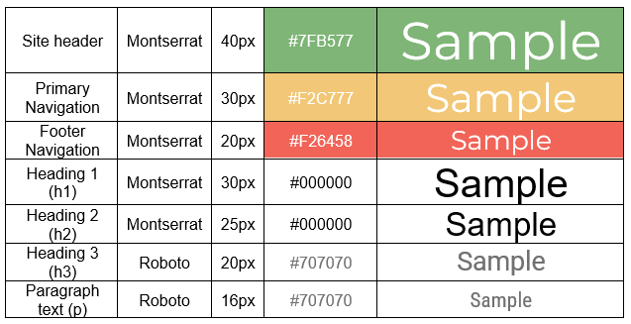

**Wireframes**

**Large View**

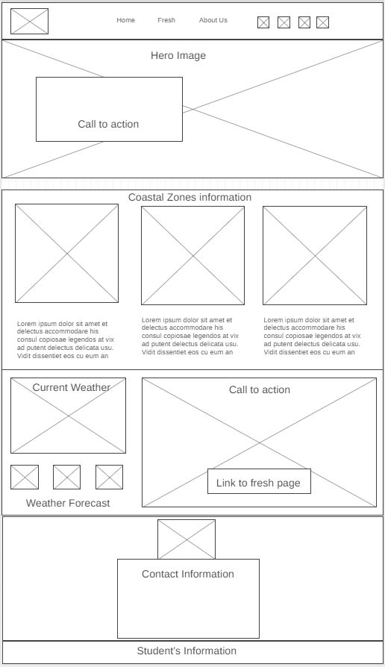

**Medium size view**

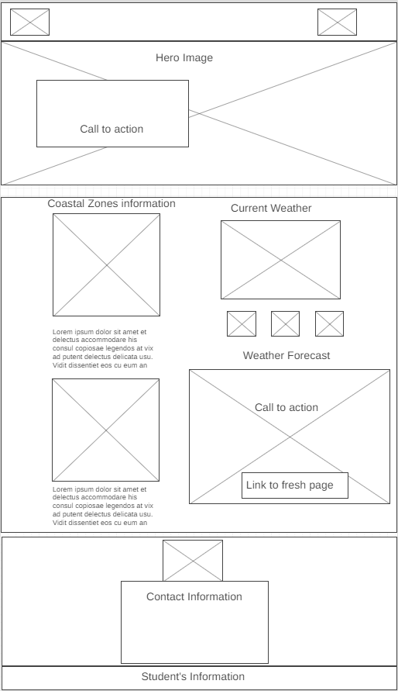

**Small view**

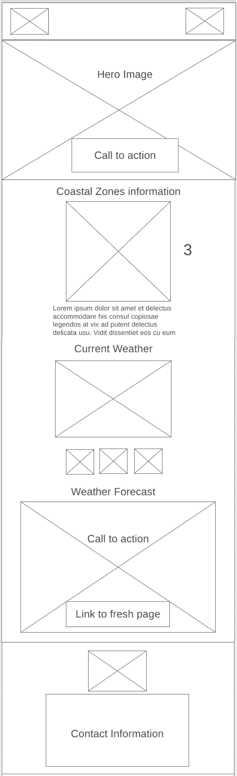

The “3” here means that there will be three information cards